Inbox & Flow Set-up
9.2.22
Inbox
- Create the following Subfolder under Inbox
0 UPLOADS with subfolders:
  - 01 COMP FLOW
  - 02 COST FLOW
  - 03 PROC FLOW
  - 04 TIME FLOW
  - 05 CHECK IN FLOW

- Create Category Tags
  - 01 COMP FLOW – Lt. Blue
  - 02 COST FLOW - Green
  - 03 PROC FLOW - Orange
  - 04 TIME FLOW - Purple
  - 05 CHECK IN FLOW – Yellow
  - COMPLETED – Pink
  - MANUAL DOWNLOAD – Red
  - NEED INFO - GRAY

- Check time zone – Settings – All Outlook Settings – General – Make sure it is USA or your time stamps won’t be accurate

- Create Rules for each area under Settings – All Outlook Settings – Rules
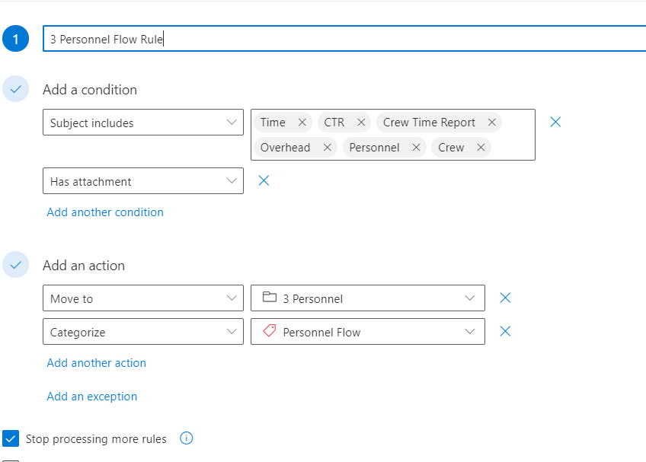

  - 01 COMP FLOW Rule
    - Key Words: COMP; CLAIMS; CLAIM

  - 02 COST FLOW Rule
    - Key Words: COST; BUYING TEAM; AIRCRAFT; BUYT; RETARDANT; HELIBASE; CATERER; SHOWER

  - 03 PROC FLOW Rule
    - Key Words: EQUIPMENT; SHIFT TICKET; SHIFT; EERA; PROC; VIPR; CONTRACTOR; LUA; ST; CONTRACT

  - 04 TIME FLOW Rule
    - Key Words: CTR; TIME; OVERHEAD; PERSONNEL; CREW

  - 05 CHECK IN FLOW Rule
    - RO; CHECK IN; CH; RED CARD; CASUAL HIRE; RESOURCE ORDER

Example after you save:
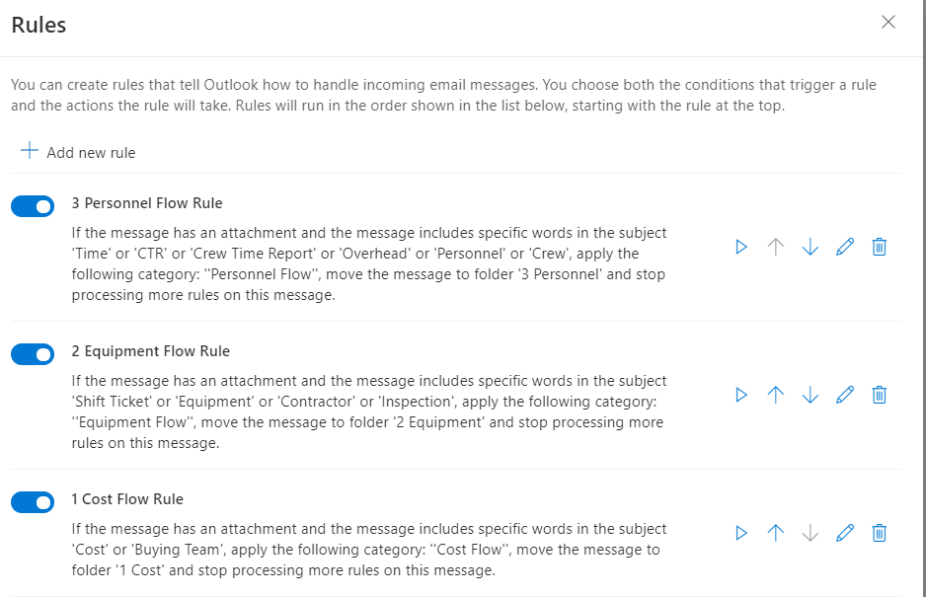

SharePoint
- Create the same subfolders under the Finance Channel Uploads (to match what you did in the inbox). This will be used in the flows to file the attachments
0 Uploads with subfolders:
  - 01 COMP FLOW
  - 02 COST FLOW
  - 03 PROC FLOW
  - 04 TIME FLOW
  - 05 CHECK IN FLOW

Power Automate – This is where you will create the flows that scan the inbox and move your attachments over to SharePoint.

- Click on the ‘My Flows’ – Shared with me. If you create ones from scratch or do a ‘Save as’ on one that is shared, it will be under ‘Shared with Me’
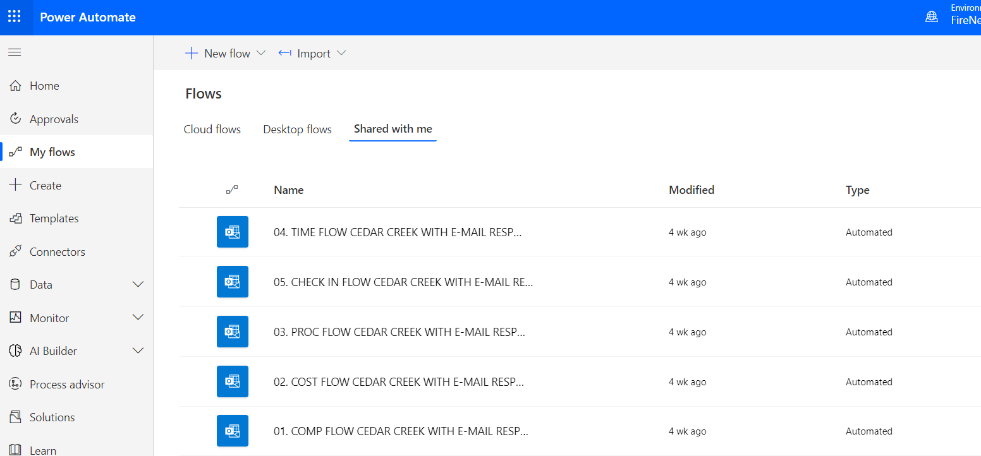

- To create new ones (for a new incident) – Click on the 3 … (dots) and choose ‘Save As’ – Give it a new name (You can also do ‘Share’ from the ... to share with someone else
  - Give it a new name to match your fire
  - Change the following fields to match your fire and modify any other ‘rules’ you want it to use (but not necessary)

- ‘When New Mail Arrives’ – Change to YOUR inbox by deleting what is there and then when you start typing it will show you the fires you have access to
- ‘Folder name’ – Click on the Folder icon to navigate to your choices – Choose the Inbox – 0 Uploads – Cost/Equip or Personnel folder (Be sure to navigate to the folder EACH time so it gets your current one.
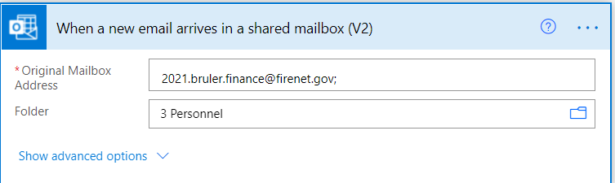

- Delay – Make sure it is set for 30 seconds
- Under ‘Apply to Each’ – Click on the ‘Condition’- Then the ‘Create file’ – Change that to your SharePoint site (it should show in the drop down for the ones you have access too, if not, type in the entire path) and folder path of this incident (navigate again on the folder path)

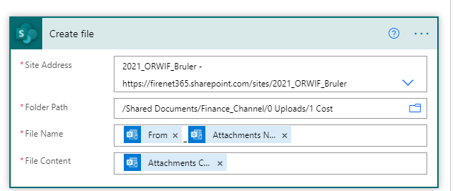

- Save everything
- Turn your flow ON – Click on dots next to the flow – Choose ‘Turn on’
- TEST by clicking on ‘Test’ in upper right
- Send an email with a keyword & attachment
- It will wait the 30 seconds then your email thru… If it all works you should see your file out in the Flow area AND in the inbox folder.

  - Repeat Step 2 for EACH flow

